**Cardiovascular Health in Teenagers**

By Taleah Ambler

**Aim**

This investigation will measure how much regular exercise affects an adolescent resting heartrate (bpm)

**hypothesis**

In this investigation, as the days the participants take part in regular exercise increases the resting bpm will decrease.

**Introduction**

Resting heart rate is the number of your times the heart beats per minute while at rest. Heart rate in teenagers’ cardiovascular health is important to take note in because of their growth. A teenagers resting heart rate is typically between 60-100 bpm (paediatric heart specialist, 2019), which is what is considered healthy in teenagers’ adolescence. Females biologically have reduced short-term resting state heart rate variability (HRV - the time interval between heartbeats) than males. Factors that affect a teenagers HRV bpm include emotions – when stressed or exited the heart beats faster (Health Direct, 2019) prevalence rates for internalizing disorders (anxiety or depression) are higher among females than males (front Physiol, 2018), air and body – on hot days body pumps more, and fitness level (Health Direct, 2019). Fitness in childhood adolescent may be linked to future cardiovascular health, a healthy level of fitness requires regular (4-5 times per week) participation in activities. Children tend to walk or bike less and increasingly rely on cars for transportation, also modern entertainment engagement including television, videogames, and computers, has increased. Sex (male and female - binary), race, level of sexual maturity, physical and mental disabilities that may affect exercise participation (AHA journals, 2002). In this investigation variables including the independent, dependant and controlled were studied close in relation to the investigation, independent being days of regular exercise, dependent including the recorded resting bpm, and controlled variables include concepts of resting for a timed minute and the pulse taken site – the wrist the base of thumb.

**Materials**

* Timer
* Data collection sheet
* Graphing paper
* Stationary (pens, pencils, erasers, correction fluid, ruler)
* Laptop
* calculator

**Method**

1. Create a draft table for data collection, including participants, their 3 trials, a space for averaging, how many days they exercise and for gender, this is for quick data collection for each trial and each participant.
2. Find approximately 20 participants in the same age group (15-16yr old’s), participants must be 15-16 so the experiment is valid for adolescents.
3. Have the participants individually sit down for a timed minute to “rest”. For this time, no talking, just sitting still is required from all participants, so the validity is kept up.
4. Pulse method is taken from the wrist below the base of the thumb and counted for 30 seconds for each trial of each participant, then it’s doubled to get an averaged BPM from all participants (this is required for later).
5. Repeat 3 times to have 3 separate trials for all 20 participants.
6. Average out these numbers by adding the individual participants 3 trials up and dividing by 3
7. Repeat step 3-6, 20 times, all controlled in the same conditions.
8. Group the data in the appropriate sample size and biological gender.
9. Average out the data in each group and each gender to get a number to use for graphing.
10. Put all data into a Bar Chart table to represent the investigation, and label the axis appropriately.

**Raw Data**

|  |  |  |  |  |  |  |
| --- | --- | --- | --- | --- | --- | --- |
| Participant | Days of exercise | Trial 1 | Trial 2 | Trial 3 | Average | F/M |
| 1 | 0-1 | 72 | 64 | 74 | 70 | F |
| 2 | 2-3 | 70 | 82 | 92 | 81 | F |
| 3 | 2-3 | 82 | 86 | 82 | 83 | F |
| 4 | 0-1 | 86 | 82 | 82 | 83 | F |
| 5 | 2-3 | 85 | 74 | 77 | 79 | F |
| 6 | 4-5 | 77 | 62 | 66 | 68 | F |
| 7 | 4-5 | 64 | 71 | 77 | 71 | F |
| 8 | 4-5 | 87 | 83 | 88 | 86 | F |
| 9 | 2-3 | 77 | 76 | 75 | 76 | M |
| 10 | 4-5 | 70 | 67 | 72 | 70 | F |
| 11 | 2-3 | 80 | 76 | 72 | 76 | M |
| 12 | 6+ | 64 | 72 | 80 | 72 | M |
| 13 | 2-3 | 78 | 78 | 80 | 79 | F |
| 14 | 2-3 | 70 | 68 | 58 | 65 | F |
| 15 | 2-3 | 72 | 76 | 70 | 73 | F |
| 16 | 4-5 | 62 | 62 | 64 | 63 | M |
| 17 | 2-3 | 76 | 80 | 72 | 76 | M |
| 18 | 4-5 | 86 | 82 | 65 | 78 | M |
| 19 | 4-5 | 80 | 88 | 90 | 86 | M |
| 20 | 4-5 | 62 | 62 | 63 | 62 | M |
| 21 | 0-1 | 80 | 76 | 78 | 78 | M |
| 22 | 6+ | 68 | 74 | 78 | 73 | F |

* Sample size

|  |  |  |
| --- | --- | --- |
| Sample size | M (average) | F(average) |
| 0-1 | 78 | 77 |
| 2-3 | 76 | 76 |
| 4-5 | 72 | 74 |
| 6+ | 72 | 73 |

**Drawn table**

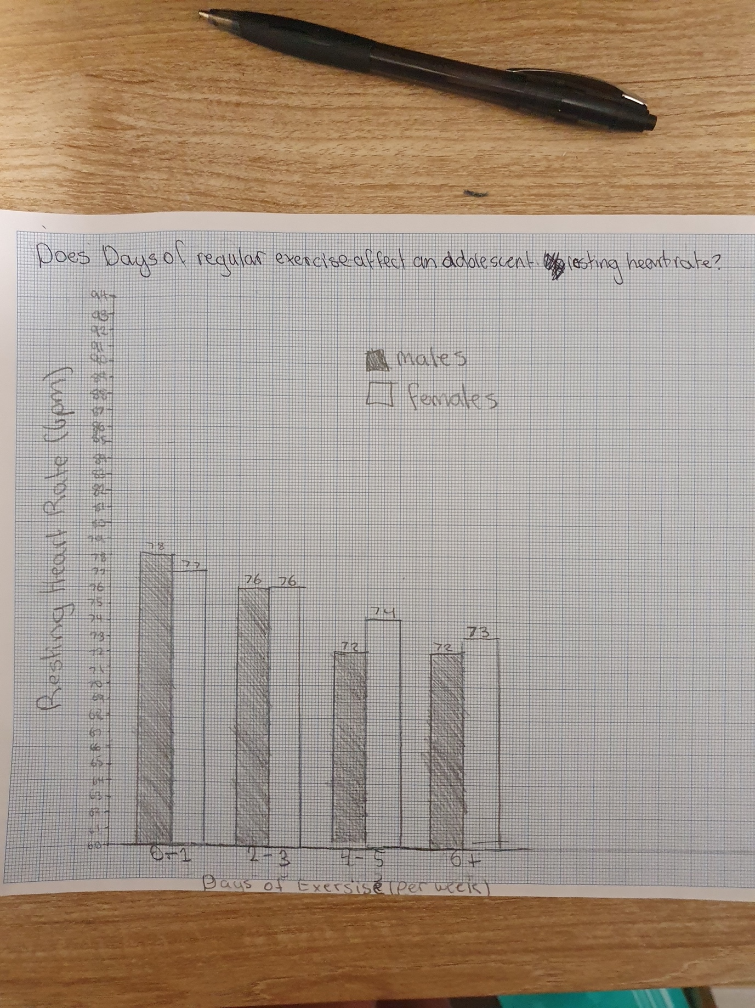

**Hypothesis & Variables**

Independent Variables – Days of exercise (per week)

Dependent Variables – Resting bpm heart rate (bpm)

Controlled Variables – resting, pulse taken from wrist.

**Outliers**

Although my graph has a decreasing trend as stated in the hypothesis on the 0-1 group the males have the average higher bpm then the females, this may be because there are 2 females to average over the one male that was in that group, and sub-factors of participant 4’s(female) mental health or any medical conditions.

**References – APA 7 Format**

* *Bradycardia - Pediatric Heart Specialists*. (2019). Pediatricheartspecialists.com. <https://pediatricheartspecialists.com/heart-education/18-arrhythmia/175-bradycardia>
* Health Direct. (2019, February 17). *Resting heart rate*. Healthdirect.gov.au; Healthdirect Australia. <https://www.healthdirect.gov.au/resting-heart-rate>
* Fiol-Veny, A., De La Torre-Luque, A., Balle, M., & Bornas, X. (2018). Altered Heart Rate Regulation in Adolescent Girls and the Vulnerability for Internalizing Disorders. *Frontiers in Physiology*, *9*. <https://www.ncbi.nlm.nih.gov/pmc/articles/PMC6046384/>
* Mintjens, S., Menting, M. D., Daams, J. G., van Poppel, M. N. M., Roseboom, T. J., & Gemke, R. J. B. J. (2018). Cardiorespiratory Fitness in Childhood and Adolescence Affects Future Cardiovascular Risk Factors: A Systematic Review of Longitudinal Studies. *Sports Medicine (Auckland, N.z.)*, *48*(11), 2577–2605. <https://doi.org/10.1007/s40279-018-0974-5>
* Williams, C. L., Hayman, L. L., Daniels, S. R., Robinson, T. N., Steinberger, J., Paridon, S., & Bazzarre, T. (2002). Cardiovascular Health in Childhood. *Circulation*, *106*(1), 143–160. <https://doi.org/10.1161/01.cir.0000019555.61092.9e>

**Planning the investigation**

Research

<https://pediatricheartspecialists.com/heart-education/18-arrhythmia/175-bradycardia>

a resting heart rate is typically between 60-100 BPM (paediatric heart specialist, N/D)

<https://www.healthdirect.gov.au/resting-heart-rate>

fitness level – low if fit.

air & body temp – on hot days body pumps more.

emotions – when stressed or overly exited your hearts beats faster.

(Health Direct, 2022)

<https://www.ncbi.nlm.nih.gov/pmc/articles/PMC6046384/>

Adolescence is a critical period for the development of mental health problems, in particular internalizing symptoms.

females have reduced short-term resting state HRV compared to males.

Studies have shown that prevalence rates for internalizing disorders (IDs; i.e., depression and anxiety) are higher among females than males

(front Physiol, 2018)

<https://www.ncbi.nlm.nih.gov/pmc/articles/PMC6182463/>

Although cardiorespiratory fitness (CRF) in childhood and adolescence may be linked to future cardiovascular health, there is currently limited evidence for a longitudinal association.

A high level of physical fitness in childhood and adolescence is associated with lower risks of future overweight, fatness, and metabolic syndrome.

(Sports Med, 2018)

<https://www.ahajournals.org/doi/full/10.1161/01.CIR.0000019555.61092.9E>

Healthy levels of physical fitness require regular (4 to 5 times per week) participation in activities

Children tend to walk or bicycle less and increasingly rely on cars for transportation.

reliance on sedentary entertainment, including television, video games, and computers, has increased.

age, sex, race, level of sexual maturity, and physical and mental disabilities that may affect exercise participation

(AHA journals, 2002)

**Sample size & Data**

|  |  |  |
| --- | --- | --- |
| Sample size | M | F |
| 0-1 | 1 | 2 |
| 2-3 | 3 | 6 |
| 4-5 | 4 | 4 |
| 6+ | 1 | 1 |